AUTOMATION GUIDELINE FOR SUITABLE TECHNOLOGY POC

PRE-CONDITION

ENVIRONMENT
- Python version 2.7 or later
- Python packages:
- Selenium version 2.53.5
- Pytest version 2.9.2
- Ddt version 1.1.0
- Pytest-html version 1.8.1
- Replace file plugin.py (from deliver package) at PythonDir\Lib\site-packages\pytest_html
- Windows 7, MAC 10.11 OS X El Capital
- Browser: IE 11, Firefox 46 or before
- URL for testing: https://staging.suitabletech.com
- Mail service for registration: Mailinator

TEST DATA
- Local test data is stored at: PROJECT_DIR/data/testdata
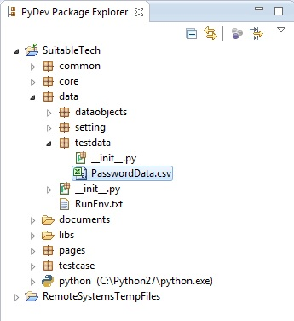

FRAMEWORK
- Our framework is based on unittest and use pytest as a test tool.
- We use ddt (version 1.1.0) for data driven and it is in python package.
- Test cases are organized by functionalities (e.g., active user, invite user, remove user, and reservation).
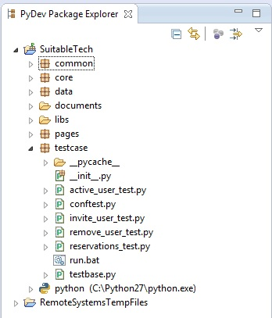
- The result of execution will be html format with the following information: summary, number of pass/fail/error, running time, environment and detail error.

AUTOMATION

LIST OF TEST CASE
Please find the list of test case in excel file with the detail status and test steps

RUNNING TEST SUITE
- Run the ‘run.bat’ file in order to execute the test
- It contents test case directory, running environment
- In case of some test cases need to be run, we add specific test file
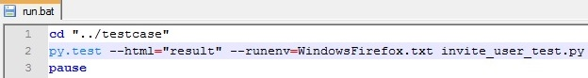
- In case of we need to run all test cases, just remove test file in pytest command line.
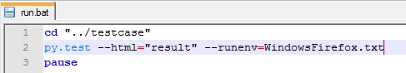
- We also can configure to run multiple environments by add more pytest command line.
